
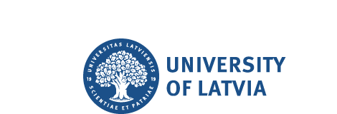
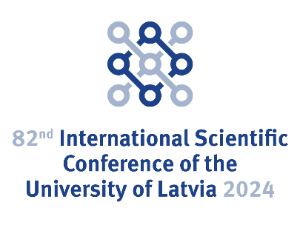
2024

82nd International Scientific Conference
University of Latvia

Use of High Performance Computing in Numerical Simulations
Book of Abstracts

Latvijas Universitātes
82. starptautiskā zinātniskā konference

Augstas veiktspējas skaitļošanas izmatošana skatliskā modelēšanā
Tēžu krājums

University of Latvia. 82nd International Scientific Conference, Use of High Performance Computing in Numerical Simulations: Book of Abstracts. Riga: University of Latvia, 2024. 15 lpp.

The 82nd International Scientific Conference of the University of Latvia.
Use of High Performance Computing in Numerical Simulations.
Book of Abstracts

Latvijas Universitātes 82. starptautiskā zinātniskā konference.
Augstas veiktspējas skaitļošanas izmantošana skatliskā modelēšanā
Tēžu krājums

Tēžu krājums publicēts autoru redakcijā

Sastādītāja: Daiga Cepīte-Frišfelde

DOI: https://doi.org/10.22364/luszk.82.hpc.ab

Augstas veiktspējas skaitļošanas izmantošana skaitliskā modelēšanā

Use of High Performance Computing in Numerical Simulations

Thursday, 22nd February 2024, 10.00 AM, University of Latvia House of Sciences, Riga, 3 Jelgavas Str. and zoom

Programma/Programme
Vadītājs/Chair: Jānis Virbulis
9.30-10.00 | Reģistrācija un kafijas pauze/Registration and Coffee
10.00–10.10 | Atklāšana/Opening
10.10–10.30 | Valters Dzelme  University of Latvia | Šķidra metāla magnetohidrodinamikas ar brīvo virsmu modelēšana  Simulation of liquid metal MHD with free surface
10.30–10.50 | Maksim Sokolov, Yuri A. Mastrikov, Guntars Zvejnieks, Eugene A. Kotomin  Institute of Solid State Physics University of Latvia | Ūdeņraža ražošanas uz pārveidotām SrTiO₃ perovskīta nanodaļiņām modelēšana – ab initio skaitliskā izpēte  Modeling of hydrogen production on stepped surfaces of SrTiO₃ perovskite nanoparticles - ab initio computational study
10.50-11.10 | Antun Balaz  Institute of Physics Belgrade, Serbia | Dipolāru kvantu gāzu skaitliskā modelēšana: no Bozes-Einšteina kondensātiem līdz supercietvielām  Numerical modeling of dipolar quantum gases: from Bose-Einstein condensates to supersolids
11.10-11.30 | Heiko Hermmann  Tallinn University of Technology (TalTech) | Šķiedru betona plūsmas OpenFOAM aprēķini  OpenFOAM Simulation of Fiber Concrete Flow
11.30-11:50 | Valters Ribickis, Valters Dzelme  University of Latvia | Siltuma apmaiņas skaitliska analīze  divu slāņu sistēmā ar pretēju šķidruma plūsmu  Numerical analysis of heat exchange in a double layer system with opposing fluid flow
11:50-12:10 | Jurijs Ješkins  University of Latvia | Augstas veiktspējas skaitļošanas praktiska demonstrācija. Jupyterhub piemērs. Jautājumi un atbildes (latviski)  HPC demonstration in practice Jupyterhub example. Questions and answers (in latvian)
12.10-12.50 | Lunch and Discussions
Vadītājs/Chair: Jānis Virbulis
12.50–13.10 | Andrejs Sabanskis, Dagis Daniels Vidulejs, Jānis Virbulis, Andris Jakovičs  University of Latvia | Gaisa dezinfekcijas ar UV attīrītāju skaitliska modelēšana  Numerical simulations of air disinfection using a UV purifier
13.10–13.30 | Andrejs Timuhins, Juris Seņņikovs, Uldis Bethers  University of Latvia | Dambju izveides novērtējums: hidroģeoloģiskās modelēšanas pieeja Lielā Pelečāres un Cenas purvos  Dam installation assessment: a hydrogeological modeling approach for Lielas Pelečāres Mire and Cenas Mire
13.30-13.50 | Kirils Surovovs, Jānis Virbulis  University of Latvia | OpenFOAM hidrodinamisko aprēķinu augstas veiktspējas skaitļošanas klasteros mērogojamības izpēte  Investigation of the scalability of OpenFOAM hydrodynamic simulations on HPC clusters
13:50-14.10 | Emanouil Atanassov, Aneta Karaivanova  Institute of Information and Communication Technologies – Bulgarian Academy of Sciences | HEMUS superdatora izpildes optimizācija  Optimization of execution on HEMUS supercomputer
14:10-14.30 | Reģistrācija un kafijas pauze/Registration and Coffee

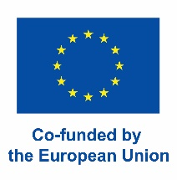

Funded by the European Union. This work has received funding from the European High Performance Computing Joint Undertaking (JU) and Germany, Bulgaria, Austria, Croatia, Cyprus, Czech Republic, Denmark, Estonia, Finland, Greece, Hungary, Ireland, Italy, Lithuania, Latvia, Poland, Portugal, Romania, Slovenia, Spain, Sweden, France, Netherlands, Belgium, Luxembourg, Slovakia, Norway, Türkiye, Republic of North Macedonia, Iceland, Montenegro, Serbia under grant agreement No 101101903.

Content

Content 6
V. Dzelme, Simulation of liquid metal MHD with free surface 7
M. Sokolov, Y. A. Mastrikov, G. Zvejnieks, E. A. Kotomin, Modeling of hydrogen production on stepped surfaces of SrTiO₃ perovskite nanoparticles - ab initio computational study 8
A.Balaž, Numerical modeling of dipolar quantum gases: from Bose-Einstein condensates to supersolids 9
H. Hermmann, OpenFOAM Simulation of Fiber Concrete Flow 10
V. Ribickis, V. Dzelme, Numerical analysis of heat exchange in a double layer system with opposing fluid flow 11
A. Sabanskis, D. D. Vidulejs, J. Virbulis, A. Jakovičs, Numerical simulations of air disinfection using a UV purifier 12
J. Sennikovs, U. Bethers, A. Timuhins, Dam installation assessment: a hydrogeological modeling approach for Lielais Pelečāres Mire and Cenas Mire 13
K. Surovovs, J. Virbulis, Investigation of the scalability of OpenFOAM hydrodynamic simulations on HPC clusters 14
E. Atanassov, A. Karaivanova, Optimization of execution on HEMUS supercomputer 15

Simulation of liquid metal MHD with free surface

Valters Dzelme

Institute of Numerical Modelling, University of Latvia

E-mail: valters.dzelme@lu.lv

Liquid metal magnetohydrodynamics (MHD) can involve many physical effects, such as electromagnetic (EM) field, turbulent fluid flow, heat transfer, solidification/melting and others. The main difficulty in simulating such processes comes from the coupling between all of the effects. For example, fluid flow can depend directly on heat transfer due to temperature-dependent physical properties of the fluid. Or the flow and free surface motion can depend on EM field distribution, which itself depends on the fluid flow and surface shape.
To save time and computer resources, it is always desirable to simplify numerical models describing complex physical processes. In MHD cases, depending on specific configuration of EM field and liquid metal shape and dynamics, different numerical approximations and simplifications are possible. However, all simplifications must be either verified against more accurate models or validated experimentally.
This work demonstrates different approaches to simulating various MHD systems with liquid metal using coupled open-source software OpenFOAM (fluid flow with Volume of Fluid (VOF) method for free surface capturing) and Elmer (EM). Simulations are validated by laboratory experiments.
One of the considered examples is liquid metal stirring by a rotating permanent magnet (Fig. 1). Two main modelling approaches can be distinguished for this case. The full model simulates the whole EM system in Elmer and turbulent two-phase flow with free surface in OpenFOAM. The EM problem is recalculated every time the free surface shape or flow velocity changes slightly. A simpler and much faster approach is solving EM induction in Elmer for a static fluid and adding a correction to the Lorentz force due to liquid metal flow in OpenFOAM. If the free surface motion influences the EM field distribution very little, this approach allows simulating Elmer only once, which reduces the total simulation time significantly.
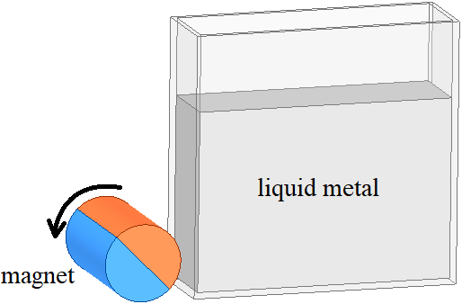 | 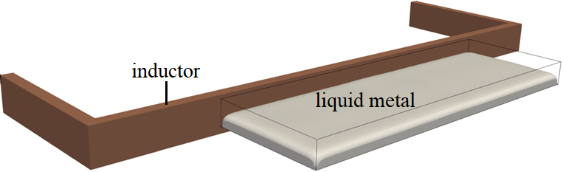
Fig. 1. Stirring with a rotating permanent magnet. | Fig. 2. Liquid metal layer in AC field.
Another example is a thin liquid metal layer in AC magnetic field (Fig. 2). In this case, only dynamic two-way coupling is appropriate due to Lorentz force concentrating on the free surface. Simulation speed-up can potentially be achieved by optimizing the numerical mesh. However, peculiar free surface instabilities occur in this system, which makes it tricky to optimize the mesh. With a coarse mesh, the instabilities are damped, leading to less oscillations and fewer EM recalculations are required. By refining the mesh, more EM recalculations are needed not only due to finer elements (EM is recalculated if the free surface moves over at least a half of a mesh cell anywhere in the domain), but also due to more oscillations being resolved. Ultimately, the minimum mesh resolution and the solution obtained with it must be validated by experiments.

Keywords:
Liquid metal, magnetohydrodynamics, numerical modelling

Modeling of hydrogen production on stepped surfaces of SrTiO₃ perovskite nanoparticles - ab initio computational study

Maksim Sokolov, Yuri A. Mastrikov, Guntars Zvejnieks, Eugene A. Kotomin

Institute of Solid State Physics, University of Latvia,

E-mail: maksims.sokolovs@cfi.lu.lv

As an important process for green energy, hydrogen production through water splitting requires a good catalyst. Strontium titanate SrTiO₃ (STO) is a sustainable material for photocatalytic water splitting, the activity of which can be further improved by creating multifaceted nanoparticles [1].
To better understand the source of the improved activity of multifaceted nanoparticles, we model the reaction using ab initio method. We created an atomistic model for the two types of nanoparticles' facets, namely, flat {001} surface and stepped {110} surface, shown in Fig. 1. We then performed density functional theory (DFT) calculations as implemented in the Vienna ab initio simulation package (VASP) [2]. The DFT calculations were executed using the High-Performance Computing Center Stuttgart (HLRS) facilities. To estimate the catalytic activity, we used the descriptor-based analysis within the computational hydrogen electrode (CHE) framework [3]. The $G_{max}(η)$ was selected as the descriptor [4].
We demonstrate that the hydrogen evolution reaction (HER, cathodic part of water splitting) is thermodynamically preferred on the flat {001} STO surface [5], while the oxygen evolution reaction (OER) is preferred on the stepped {110} surface [6]. These observations are consistent with the experimental data [1]. Moreover, for the OER, we investigate several possible reaction pathways and find the energetically favorable ones. Thus, we shed light on the process of water splitting on both multifaceted as well as cubic nanoparticles.
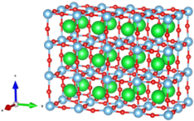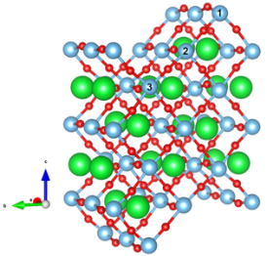
Fig. 1. Left – Flat {001} STO surface; right – Stepped {110} STO surface with denoted sites: 1 – ridge, 2 – slope, 3 – gully.
References:
- L. Mu et al., “Enhancing charge separation on high symmetry SrTiO3 exposed with anisotropic facets for photocatalytic water splitting,” Energy and Environmental Science, vol. 9, no. 7, pp. 2463–2469, 2016, doi: 10.1039/c6ee00526h.
- G. Kresse and J. Furthmüller, “Efficient iterative schemes for ab initio total-energy calculations using a plane-wave basis set,” Physical Review B, vol. 54, no. 16, pp. 11169–11186, Oct. 1996, doi: 10.1103/PhysRevB.54.11169.
- J. K. Nørskov et al., “Origin of the overpotential for oxygen reduction at a fuel-cell cathode,” Journal of Physical Chemistry B, vol. 108, no. 46, pp. 17886–17892, 2004, doi: 10.1021/jp047349j.
- K. S. Exner, “A universal descriptor for the screening of electrode materials for multiple-electron processes: Beyond the thermodynamic overpotential,” ACS Catalysis, vol. 10, no. 21, pp. 12607–12617, 2020, doi: 10.1021/acscatal.0c03865.
- M. Sokolov et al., “First Principles Calculations of Hydrogen Evolution Reaction and Proton Migration on Stepped Surfaces of SrTiO ₃,” Advcd Theory and Sims, p. 2200619, Jan. 2023, doi: 10.1002/adts.202200619.
- M. Sokolov et al., “Computational Study of Oxygen Evolution Reaction on Flat and Stepped Surfaces of Strontium Titanate.,” submitted, 2024.
Keywords:
DFT, water splitting, hydrogen evolution reaction, oxygen evolution reaction
Acknowledgments:
The study has been financially supported by the EraNet “Engineering of two-dimensional heterostructural photocatalysts for hydrogen generation” (HetCat) project; Nr. ES RTD/2023/10. Calculations have been performed at the HLRS facility (Stuttgart) within the framework of the DEFTD 12939 project.

Numerical modeling of dipolar quantum gases: from Bose-Einstein condensates to supersolids

Antun Balaž

Institute of Physics Belgrade, Pregrevica 118, 11080 Belgrade, Serbia

E-mail: antun@ipb.ac.rs

Ultracold gases at quantum degeneracy offer intriguing prospects for various technological applications, from quantum sensing to quantum computing. Bosonic atomic and molecular species exhibit a phase transition to a Bose-Einstein condensate at sufficiently low temperatures, a state of matter that does not have a classical counterpart. The detailed numerical modeling of such systems is essential for their understanding from a fundamental point of view, and even more so for applications that require precise knowledge of their properties and efficient methods to engineer and tailor them to satisfy practical requirements.
In the mean-field approximation, Bose-Einstein condensates can be described by the Gross-Pitaevskii equation, a Schrödinger-type equation that includes nonlinear terms arising from the system's interactions. In the case of contact interactions, the corresponding nonlinear term is local, while nonlocal terms may stem from long-range interactions, such as dipole-dipole interactions, which are expressed by an integral kernel. In order to study ground states and dynamics of Bose-Einstein condensates with contact and dipolar interactions, we have developed several parallel algorithms and programs [1-10] based on the Crank-Nicolson semi-implicit split-step method, which use different levels of parallelism: OpenMP, MPI, CUDA, and their hybrid combinations.
In this talk we will give an overview of these programs and show how they can be used to study quantum droplets and vortices in strongly dipolar condensates. Such multiscale systems require numerical simulations in high resolution and therefore parallelization and use of high-performance computing is necessary for their realistic description, in particular in 3D.
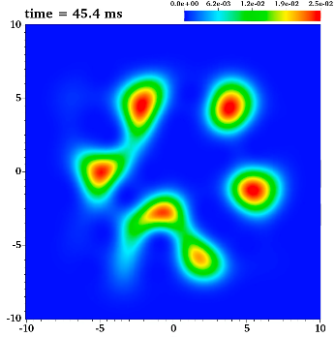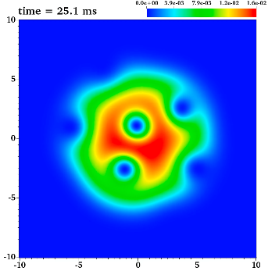
Fig. 1: Quantum droplets and vortices in a rotating dipolar Bose-Einstein condensate of ¹⁶⁴Dy.
References:
[1] D. Vudragović et al., Comput. Phys. Commun. 183, 2021 (2012).
[2] R. Kishor Kumar et al., Comput. Phys. Commun. 195, 117 (2015).
[3] B. Satarić et al., Comput. Phys. Commun. 200, 411 (2016).
[4] V. Lončar et al., Comput. Phys. Commun. 200, 406 (2016).
[5] L. Young-S. et al., Comput. Phys. Commun. 204, 209 (2016).
[6] V. Ločcar et al., Comput. Phys. Commun. 209, 190 (2016).
[7] R. Kishor Kumar et al., Comput. Phys. Commun. 240, 74 (2019).
[8] R. Ravisankar et al., Comput. Phys. Commun. 259, 107657 (2021).
[9] P. Muruganandam et al., Comput. Phys. Commun. 264, 107926 (2021).
[10] L. Young-S. et al., Comput. Phys. Commun. 286, 108669 (2023).

Keywords:
Parallel numerical simulation; Partial differential equation; Crank-Nicolson method; Dipolar interaction; Bose-Einstein condensation

OpenFOAM Simulation of Fiber Concrete Flow

Heiko Herrmann

Tallinn University of Technology, Departament of Cybernetics

E-mail: Heiko.Herrmann@taltech.ee

Fiber concrete is a type of concrete in which up to 5 cm long fibers are added at the mixing stage. These fibers are meant to partly or completely replace traditional rebar reinforcement. Fiber orientations are influenced by the flow and vibrating of the fresh concrete mass. In the presentation, simulations of the flow of fresh self-levelling concrete with fibers will be presented. The simulations are performed with a modified interFoam solver of OpenFOAM, to which a tensorial evolution equation for the orientation tensor has been added. The simulation makes it possible to predict fiber orientations before the casting and to optimize casting procedures and casting points. Several different casting cases will be shown.

Keywords:
OpenFOAM, Fiber Concrete, Rheology, simulation

Numerical analysis of heat exchange in a double layer system with opposing fluid flow

Valters Ribickis, Valters Dzelme

Institute of Numerical Modelling, University of Latvia, Jelgavas Street 3, Riga, LV-1004, Latvia

E-mail: valters.ribickis@lu.lv

This investigation focuses on a model of an incubator screen for the purpose of regulating the temperature in a given space. The screen consists of an airflow channel with a ”u” shaped bend with hot air flowing into the inlet. The surrounding space is heated through the plastic walls of the screen.
Parameter analysis was performed to find out how a change in the velocity of the inflowing hot air, the ambient room temperature and the emissivity coefficient of the wall material might influence the heat flux from the walls of the screen.
The findings of this investigation show that increasing the velocity of the inflowing air increases the heat flux from the walls, as does lowering the ambient temperature of the surrounding space and increasing in the emissivity coefficient of the material used for the walls.

Keywords:
Heat exchange, airflow

Numerical simulations of air disinfection using a UV purifier

Andrejs Sabanskis, Dagis Daniels Vidulejs, Jānis Virbulis, Andris Jakovičs

Institute of Numerical Modelling, University of Latvia, Jelgavas 3, Riga, Latvia

E-mail: andrejs.sabanskis@lu.lv

Besides using air purifiers with HEPA filters, an effective method of reducing concentration of infectious aerosols indoors is the use of UV light. The efficiency of a portable air purifier depends on several factors, for example, the flow rate, power (number) of UV lamps and purifier orientation and placement in a room. A realistic setup based on an existing prototype of the air purifier in a 3x3x3 m³ test stand is considered in [1]. The evaluation of many scenarios on a high-performance computing cluster of the University of Latvia concludes that the most efficient purification overall is achieved using the vertically oriented purifier.
However, in [1], individual fans were not resolved in the air flow simulations, and the UV irradiation was modelled in a simplified way. A more advanced representation of the purifier, including individual UV lamps and fans, are presented in a follow-up work [2]. As shown in Fig. 1, the system geometry is simplified compared to the detailed CAD model, but the most important internal components – UV lamps, top and bottom particle filters, fans, as well as the top and bottom lids (“diffusers”) – are included in the simulations. This allows for a more accurate description of the spatial distribution of the UV irradiation (see Fig. 1, right) and the air flow. The purification efficiency is analysed for different number of UV lamps and flow rates.
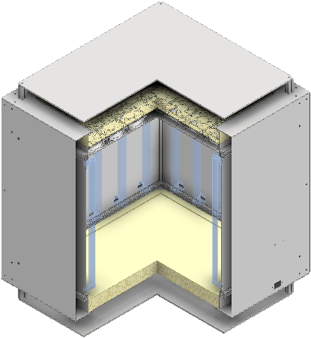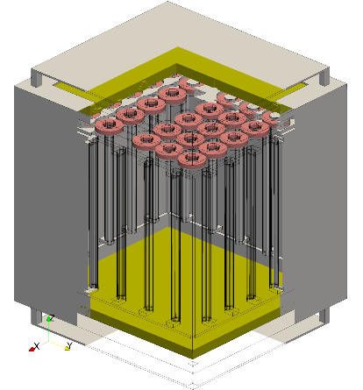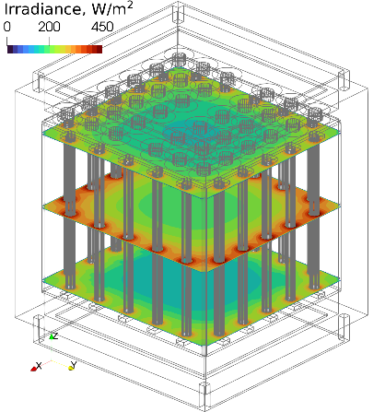
Fig. 1. Left: CAD drawing of the air purifier showing UV lamps and top and bottom particle filters; centre: simplified air purifier geometry used in the simulations; right: distribution of irradiance inside the purifier created by the UV lamps.

References:
- A. Sabanskis, D. D. Vidulejs, J. Teličko, J. Virbulis, and A. Jakovičs, “Numerical evaluation of the efficiency of an indoor air cleaner under different heating conditions,” Atmosphere, vol. 14, no. 12, 2023, doi: 10.3390/atmos14121706.
- A. Sabanskis, D. D. Vidulejs, J. Virbulis, and A. Jakovics, “CFD analysis of airborne pathogen disinfection in a UV-C air purification device,” Latvian Journal of Physics and Technical Sciences, vol. 60, no. s6, pp. 20–34, 2023, doi: 10.2478/lpts-2023-0042.
Keywords:
Computational fluid dynamics, UV disinfection, air filtering, aerosol transport
Acknowledgements:
The present research has been supported by the European Regional Development Fund, Project “System for prediction and reduction of COVID-19 infection risk in indoor environment”, No. 1.1.1.1/21/A/046.

Dam installation assessment: a hydrogeological modeling approach for Lielais Pelečāres Mire and Cenas Mire

Juris Seņņikovs, Uldis Bethers, Andrejs Timuhins

Institute of Numerical Modelling Faculty of Physics, Mathematics, and Optometry University of Latvia

E-mail: andrejs.timuhins@lu.lv

The aim of this work was an estimation of the peat restoration measures (damming in ditches) assessment. For this purpose, the hydrogeological model of a raised bog was developed. The model is based on the MODFLOW software. The time series of the water table for Lielas Pelečāres Mire and Cenas Mire from 2008 to 2018 was calculated for several scenarios: with undammed channels, with dammed channels and the "natural" state - without channels. The impact of the installation of dams on the water table in both bogs was analyzed. This work was carried out within the framework of the LIFE PeatCarbon project.

Keywords:
Peat restoration, water table, dam

Investigation of the scalability of OpenFOAM hydrodynamic simulations on HPC clusters

Kirils Surovovs, Jānis Virbulis

University of Latvia, Institute of Numerical Modelling, Jelgavas 3, Riga, Latvia

E-mail: kirils.surovovs@lu.lv

OpenFOAM is a free open-source software that is frequently used for computational fluid dynamics. Due to large mesh sizes and complexity of equations in typical nowadays problems – several million or more elements – parallel computing often is inevitable. However, the higher the number of used cores, the more resources are spent on communication between processors, data transfer and other operations. It is important to ensure the required speed-up and the efficient use of resources during the high-performance computing (HPC).
Previously the scalability tests were performed on University of Latvia (LU) [1] and Riga Technical University (RTU) [2] clusters. The communication time and other productivity losses increased so much when multiple nodes were used, that the number of finite volume operations per second practically did not increase. The present work describes the similar tests performed on the Luxembourg supercomputer MeluXina, which is the 12th most powerful cluster in the EU [3].
The MeluXina cluster demonstrated significantly better scalability of parallel HPC simulations. An example of a good result is almost 14-fold speed-up with the 3.2 million cells grid, while core number increased from 2 to 16. Such speed-up is superlinear (the decrease in time is larger than the increase in core number), thus HPC resources are used efficiently. Another successful result is shown in Fig. 1, top right: the increase of the number of used nodes from 1 to 2 allowed to decrease simulation time more than twice, due to the efficient use of CPU cache memory.
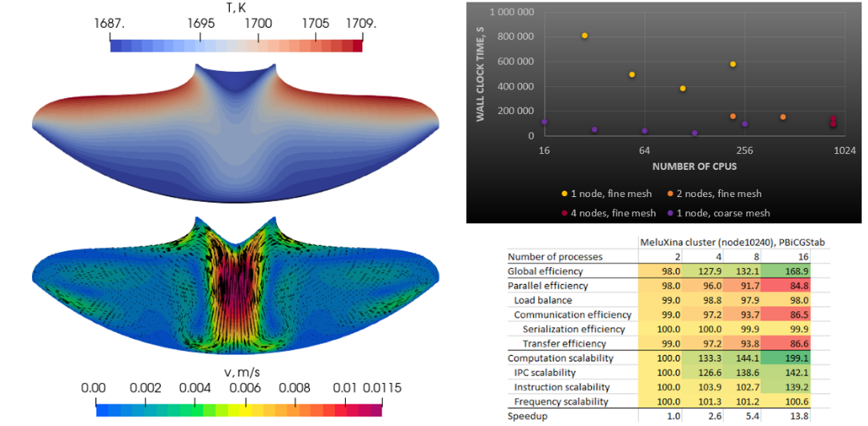
Fig. 1. Left – examples of the obtained results: silicon temperature (top) and melt velocity (bottom). Right – scaling of computation time (top) and performance metrics (bottom) on MeluXina cluster.
References:
[1] https://modinst.lu.lv/en/pakalpojums/augstas-veiktspejas-aprekini/
[2] https://hpc.rtu.lv/?lang=en
[3] https://luxembourg.public.lu/en/invest/innovation/meluxina-supercomputer.html
Keywords:
parallel simulations, scalability, OpenFOAM

Optimization of execution on HEMUS supercomputer

Emanouil Atanassov and Aneta Karaivanova

Institut for Information and Communication Technologies - BAS, Acad. G. Bonchev St., bl.25A, Sofia 1113, Bulgaria

E-mail: anet@parallel.bas.bg

Bulgaria has a long tradition of high performance computing (HPC) and an extensive experience in solving challenging problems in science and its applications. In October 2023, the new petascale supercomputer HEMUS came into operation at the Institute of Information and Communication Technologies, Bulgarian Academy of Sciences. The HEMUS supercomputer has a peak performance of over 3 PetaFlops, 148 servers distributed in two subsystems and non-blocking InfiniBand connectivity. The universal multi-core processor subsystem consists of 128 dual-processor HPE ProLiant XL220n Gen10 Plus servers with direct liquid cooling. The subsystem with universal multi-core processors and graphics accelerators consists of 20 HPE ProLiant XL675d dual-processor servers with direct liquid cooling of the CPUs and GPUs.
The system was ranked 360th in the November 2023 Top500 list of the most powerful supercomputers, after achieving a LINPACK performance of 2.53 PetaFlops on the standard High Performance Linpack (HPL) benchmark.
The supercomputer was deployed within the framework of the project Center of Excellence in Informatics and ICT, funded by the Operational Program "Science and Education for Smart Growth". It is part of a new infrastructure complex in IICT including the supercomputer HEMUS, a data storage and processing system with a capacity of more than 6.72 PetaBytes, high performance server systems for application development and digitization facilities. For an efficient and convenient user experience all layers of the computing ecosystem are well integrated, including the network, computing resources, data, software, services and tools,.
Numerous tests, both global HPL-type and micro-benchmarks, were carried out, which helped to optimally configure the system and shape approaches for the most effective use of HEMUS’s capabilities in the migration and optimization of applications. Data storage systems with high capacity and performance, supporting a variety of protocols and options for working with containers, were installed and integrated with HEMUS, in order to give adequate support for I/O operations in data-intensive applications. The first applications migrated to HEMUS are in the fields of artificial intelligence and climatology.
In this talk we will present optimization of execution on HEMUS supercomputer and will show various examples.

Keywords:
HPC, supercomputer, benchmark tests, intensive applications, optimization

